TrueSTUDIO & Drone Setup and Configuration

- Download & Install TrueStudio newest version
  - https://atollic.com/truestudio/

- Download & Install St-link utility
  - https://www.st.com/en/development-tools/st-link-v2.html#tools-software

- Clone/download template file
  - https://github.com/stevof12/Drone_Student

- Open St-Link utility and click the connect button (looks like a plug) and make sure it is connected properly

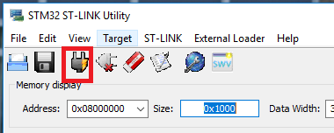

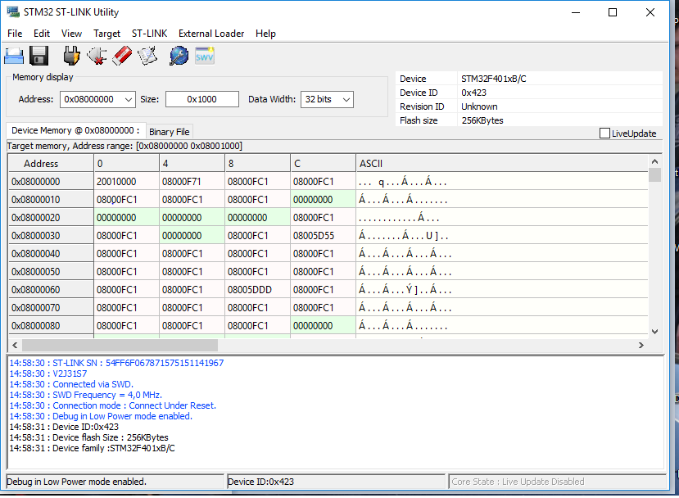

- Now click Disconnect
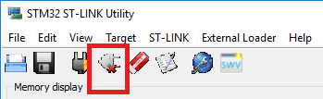

- Download the student template code from:
  - https://github.com/stevof12/Drone_Student
- Extract the zip file to a new folder in your documents called “Drone_labs”
- Open TrueStudio
  - Select your workspace to be the Drone_labs folder.
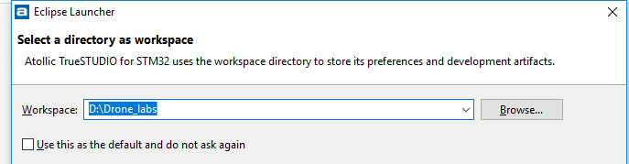
  - File->Import
  - General->Existing Projects into workspace
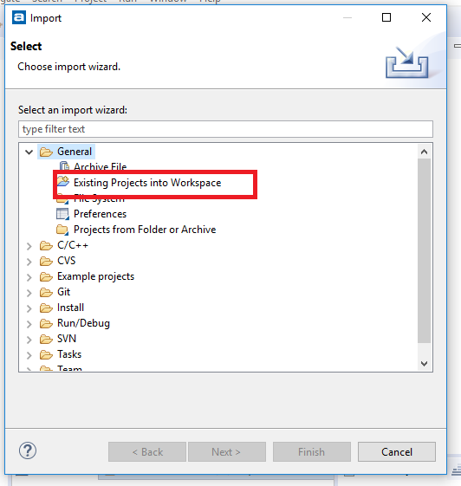
  - Select root directory to Drone_labs
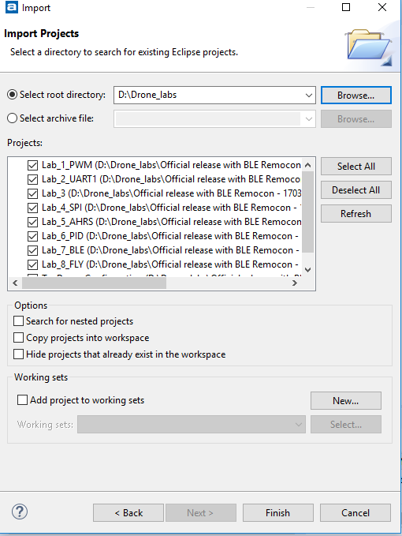
  - Select all 8 lab folders and click finish.
  - All eight lab template files should now be imported

- To flash the board, you click the debug icon under projects
  - When Debugging you can check the registers b
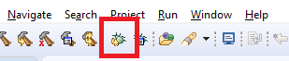
- It will take a few minutes to build the project for the first time.

- You should now see Green/red flashing on the ST Link tool

- If you do not and get ST-Link not found or Debugger not found, unplug and plug the board and the ST-Link back in again.

